# Medical Device Inventory Management

## Project/problem Overview

With the widespread spread of COVID-19, medical devices and equipment, tools that clinicians use to deliver patient care, have become increasingly scarce. In addition, many medical devices are extremely complex and expensive to buy and expensive to maintain. However, they are crucial to patient safety. This program aim to develop effective ways of utilizing their expensive medical equipment. We want to share expensive equipment in their service provider network, such as a hospital. Therefore, there is no need to purchase expensive equipment that is not often used. In addition, good management of equipment utilization can have an impact on clinical operations, such as surgery, which are heavily dependent on the availability of medical equipment. In other words, good management of equipment inventory means efficient use of the operating room and efficient use of clinician time and staff time.

Obviously, the effective management of medical equipment can improve the utilization rate of medical resource. At the same time, make medical establishment more efficiently and effectively by reduce unnecessary work.

**Proposed Entities**

1. System
2. Network
3. Enterprise: Enterprise detailed information

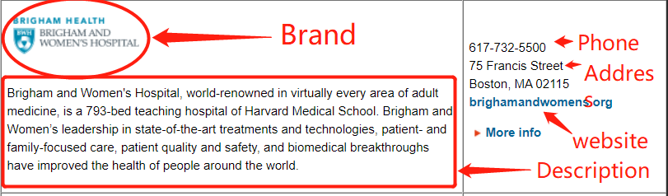

Hospital: hospital like Brigham and Women's Hospital, Massachusetts General Hospital, etc.

Supplier: supplier include many hospitals and other medical products and services provider like AllWays Health Partners(health insurance) .

1. Organization:

Organization under Hospital:

* Medical department: MD&DO who can apply a clinical operations and become the leader of a care team.

NP&APRN who can become the member of care team.

* Inventory department: medical device (each medical device has an available time table)
* Financial department: payment method for medical device supplier.

Organization under Supplier:

* Financial department
* Inventory department

## Application Key Functionalities

**Network Staff**/**Hospital Admin**/**Organization Admin:**

1. Create new entities
2. Allocate account and password

### Doctor:

1. Create schedule of clinical procedures
2. View all surgery scheduling
3. View time table of medical device and other detailed information of device
4. View time table of room
5. Search available room and medical device

### Nurse:

1. Join care team of the clinical procedure
2. View themselves’ scheduling time table

### Warehouse manager

1. Create schedule of required medical device according to the clinical procedures created by doctor.
2. View time table of medical device and other detailed information of device

### Accountant

1. View payment history
2. Send / receive funds

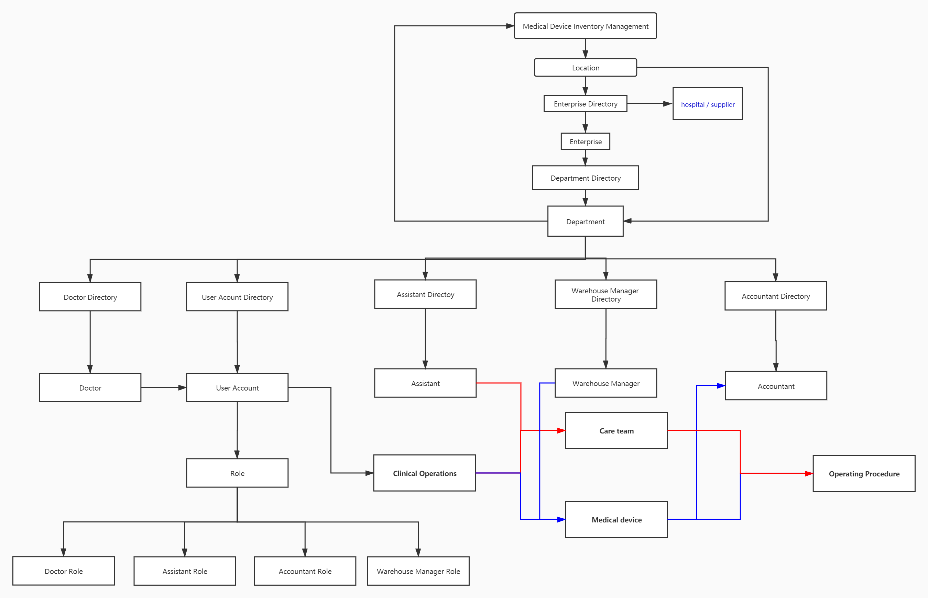

Figure 1 Architecture of ecosystem

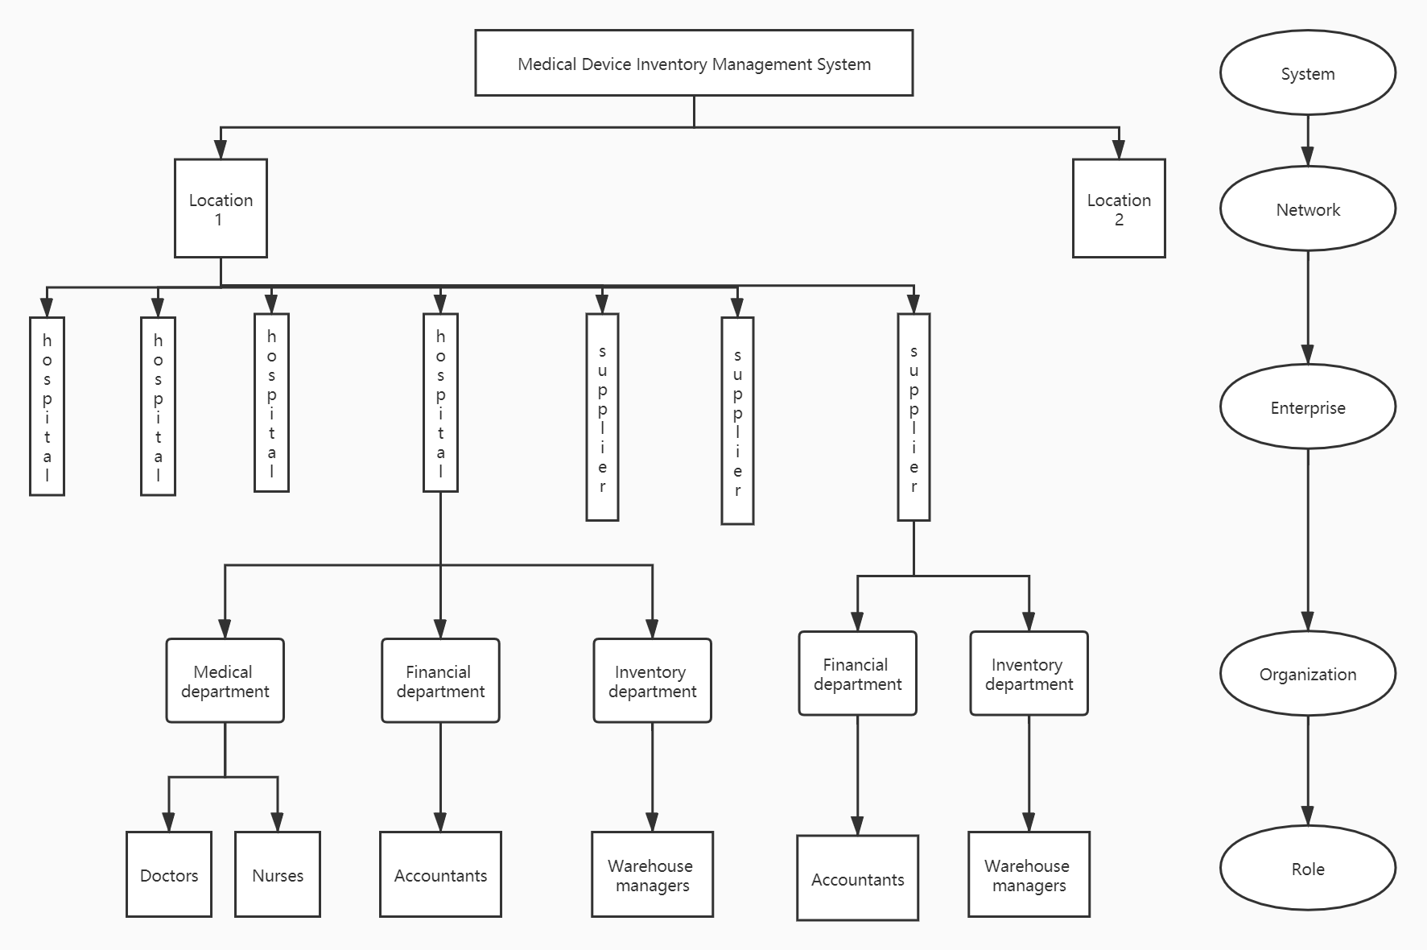

Figure 2 Hierarchical structure of ecosystem